**North Oakview Art News**

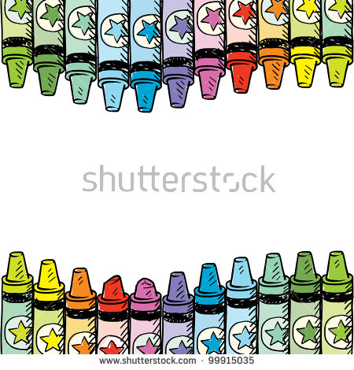

***September - 2017***

I am excited to start another wonderful year of Art here at North Oakview! There are many fun lessons planned for your student to be engaged in. Because learning in Art class can be messy most days, please note which day of the week your child will have art and try to avoid new/nice clothing that day of the week. We will always wear Art smocks but it's good to be prepared for the day.

**This is what you can expect your child to be learning in Art this year:**

The elementary visual arts program enables students to see connections in the ever changing visual culture and how that impacts their lives. Emphasis is placed on the process of exploring a variety of subject, media, technique and themes through studio activity, and discussion about works of art to develop critical thinking, communication and visual literacy skills.

Kindergarten- Our students will:

* develop independence
* explore a variety of art materials and use them safely and appropriately
* improve fine motor skills
* explore the basic elements of art: line, color, shape and texture
* describe what is seen, both literal and expressive, in selected works of art
* look at and discuss art from a variety of times and places

1st and 2nd Grade- Our students will:

* demonstrate independence
* accept diversity in art: historically, culturally and personally
* apply prior skill development
* participate in discussions about works of art: compare and contrast, communication of moods and emotion
* expand their understanding of the elements and principles of design
* explore universal themes such as environment, community, human issues and communication

3rd and 4th Grade- Our students will:

* know and apply the use of tools, materials, techniques and processes of art
* participate in discussions about works of art: compare and contrast, analyze and interpret the meaning of a work of art, communication of moods and emotion
* use visual art vocabulary when discussing art
* explore universal themes used by artists such as environment, community, human issues and communication
* apply problem solving and divergent thinking skills in the creative process
* recognize and appreciate diversity in art

  
I plan to continue our participation on the art website *Artsonia* with which I photograph your student’s artwork and place it online for friends and family to view. If you are new to this program, you will be receiving a permission form to allow your child’s artwork to be shown online soon. Our Artsonia website is at **http://www.artsonia.com/schools/ school.asp?id=8536**



You can also stay up to date with all the special things going on in the Art room by visiting our classroom website at **http://northoakviewart.weebly.com**



I am looking forward to another fun and successful school year filled with wonderful artwork to create, share and enjoy together!

~Mrs. Haugen rhaugen@nvps.net